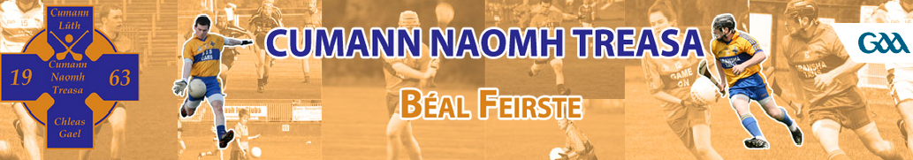

Standing Order Form 2017
Your Bank Details (PLEASE COMPLETE IN BLOCK CAPITALS)
To: The Manager
Bank/Building Society
Address
Post Code
Name(s) of Account Holder(s)

Sort Code Account Number

Your reference (will appear on your bank statement)
NAOMH TREASA CLG MEMBERSHIP

Please pay to the Danske Bank Account 91009672 Sort Code 95-01-03 of
'St. Teresa's Gaelic Athletic Association Club',
Kennedy Centre, 564 - 568 Falls Road, Belfast Co. Antrim BT11 9AE
the sum of £20 on the 1st day February 2017 and thereafter monthly payments of £10 until further notice.

(Usual Signature)

